**Q.1 Student Information Table**

mysql> create database sqltask;

Query OK, 1 row affected (0.02 sec)

mysql> use sqltask;

Database changed

mysql> create table student(rollno int,name varchar(20),percentage float,address varchar(50));

Query OK, 0 rows affected (0.03 sec)

mysql> desc student;

+------------+---------------+-------+-----+---------+-------+

| Field | Type | Null | Key | Default | Extra |

+------------+---------------+-------+-----+---------+-------+

| rollno | int | YES | | NULL | |

| name | varchar(20) | YES | | NULL | |

| percentage | float | YES | | NULL | |

| address | varchar(50) | YES | | NULL | |

+------------+---------------+------+-----+---------+--------+

4 rows in set (0.00 sec)

mysql> insert into student(rollno,name,percentage,address) values (1,'Samiksha',88.50,'Kolhapur');

Query OK, 1 row affected (0.02 sec)

mysql> insert into student(rollno,name,percentage,address) values (2,'Sanket',78,'Panhala');

Query OK, 1 row affected (0.02 sec)

mysql> insert into student(rollno,name,percentage,address) values (3,'Aarvi',92.30,'Kolhapur');

Query OK, 1 row affected (0.01 sec)

mysql> insert into student(rollno,name,percentage,address) values (4,'Soham',74.50,'Mumbai');

Query OK, 1 row affected (0.01 sec)

mysql> insert into student(rollno,name,percentage,address) values (5,'Asmita',80,'Satara');

Query OK, 1 row affected (0.01 sec)

**Output:**

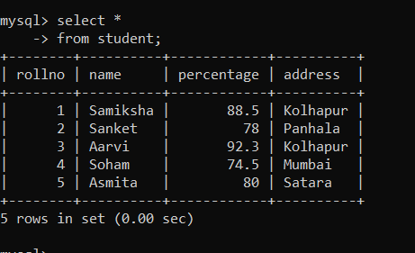

**Q.2 Employee Information Table**

mysql> create table employee(eid int,ename varchar(20),salary int,designation varchar(50));

Query OK, 0 rows affected (0.08 sec)

mysql> desc employee;

+-------------+---------------+-------+-----+----------+-------+

| Field | Type | Null | Key | Default | Extra |

+-------------+---------------+-------+-----+----------+-------+

| eid | int | YES | | NULL | |

| ename | varchar(20) | YES | | NULL | |

| salary | int | YES | | NULL | |

| designation | varchar(50) | YES | | NULL | |

+-------------+---------------+-------+-----+----------+-------+

4 rows in set (0.01 sec)

mysql> insert into employee(eid,ename,salary,designation) values (1,'Shrisha',40000,'Software Engineer');

Query OK, 1 row affected (0.04 sec)

mysql> insert into employee(eid,ename,salary,designation) values (2,'Nikhil',55000,'IT Manager');

Query OK, 1 row affected (0.03 sec)

mysql> insert into employee(eid,ename,salary,designation) values (3,'Radha',35000,'System Analyst');

Query OK, 1 row affected (0.01 sec)

mysql> insert into employee(eid,ename,salary,designation) values (4,'Yash',40000,'Front-end Developer');

Query OK, 1 row affected (0.01 sec)

mysql> insert into employee(eid,ename,salary,designation) values (5,'Sanyogita',42000,'Network Engineer');

Query OK, 1 row affected (0.02 sec)

**Output:**

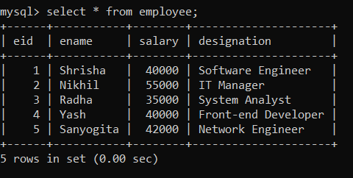

**Q.3 Doctor Information Table**

mysql> create table doctor(did int,dname varchar(20),email varchar(50),phoneno varchar(15),salary int,specialization varchar(50));

Query OK, 0 rows affected (0.04 sec)

mysql> desc doctor;

+----------------+---------------+-------+-----+---------+-------+

| Field | Type | Null | Key | Default | Extra |

+----------------+---------------+-------+-----+---------+-------+

| did | int | YES | | NULL | |

| dname | varchar(20) | YES | | NULL | |

| email | varchar(50) | YES | | NULL | |

| phoneno | varchar(15) | YES | | NULL | |

| salary | int | YES | | NULL | |

| specialization | varchar(50) | YES | | NULL | |

+----------------+--------------+--------+-----+---------+-------+

6 rows in set (0.00 sec)

mysql> insert into doctor(did,dname,email,phoneno,salary,specialization) values (1,'Dr.Subhash Patil','subhash123@gmail.com',9096366112,50000,'Psychiatrist');

Query OK, 1 row affected (0.02 sec)

mysql> insert into doctor(did,dname,email,phoneno,salary,specialization) values (2,'Dr.Nitin Shaha','shahanitin03@gmail.com',9665812776,80000,'Surgen');

Query OK, 1 row affected (0.02 sec)

mysql> insert into doctor(did,dname,email,phoneno,salary,specialization) values (3,'Dr.Samruddhi Patil','samru24@gmail.com',8888784153,70000,'Dentist');

Query OK, 1 row affected (0.02 sec)

mysql> insert into doctor(did,dname,email,phoneno,salary,specialization) values (4,'Dr.Soniya Jadhav','jadhavsonu@gmail.com',9067680707,95000,'Gynecologist');

Query OK, 1 row affected (0.02 sec)

mysql> insert into doctor(did,dname,email,phoneno,salary,specialization) values (5,'Dr.Sparsh Mane','sparsh00@gmail.com',9067782776,70000,'Pediatrician');

Query OK, 1 row affected (0.02 sec)

**Output:**

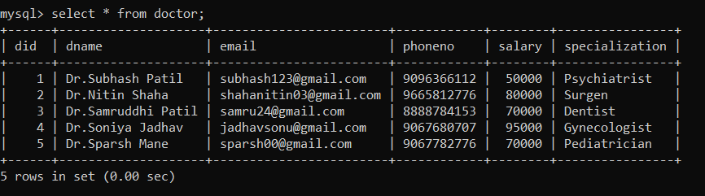

**Q.4 Book Information Table**

mysql> create table book(bid int,bname varchar(20),author varchar(20),publication varchar(50),price int);

Query OK, 0 rows affected (0.04 sec)

mysql> desc book;

+--------------+--------------+-------+------+----------+-------+

| Field | Type | Null | Key | Default | Extra |

+--------------+--------------+-------+------+----------+-------+

| bid | int | YES | | NULL | |

| bname | varchar(20) | YES | | NULL | |

| author | varchar(20) | YES | | NULL | |

| publication | varchar(50) | YES | | NULL | |

| price | int | YES | | NULL | |

+--------------+--------------+-------+------+---------+-------+

5 rows in set (0.01 sec)

mysql> insert into book(bid,bname,author,publication,price) values (101,'Gitanjali','Rabindranath Tagore','Nirali',450);

Query OK, 1 row affected (0.02 sec)

mysql> insert into book(bid,bname,author,publication,price) values (102,'Shamchi Aai','Sane Guruji','Vijayshri',200);

Query OK, 1 row affected (0.02 sec)

mysql> insert into book(bid,bname,author,publication,price) values (103,'World War','W.churchill','Goodbooks',400);

Query OK, 1 row affected (0.01 sec)

mysql> insert into book(bid,bname,author,publication,price) values (104,'Chhava','Shivaji Sawant','Mehta Book House ',450);

Query OK, 1 row affected (0.01 sec)

mysql> insert into book(bid,bname,author,publication,price) values (105,'Paradise Lost','John Milton','goodbooks',300);

Query OK, 1 row affected (0.02 sec)

**Output:**

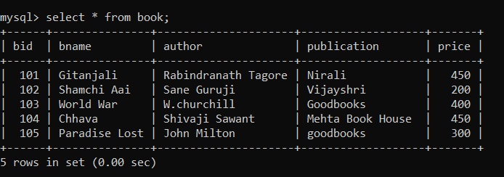

**Q.4 Patient Information Table**

mysql> create table patient(pid int,pname varchar(30),address varchar(50),disease varchar(50),test varchar(50));

Query OK, 0 rows affected (0.06 sec)

mysql> desc patient;

+---------+---------------+------+------+---------+-------+

| Field | Type | Null | Key | Default | Extra |

+---------+---------------+------+------+---------+-------+

| pid | int | YES | | NULL | |

| pname | varchar(30) | YES | | NULL | |

| address | varchar(50) | YES | | NULL | |

| disease | varchar(50) | YES | | NULL | |

| test | varchar(50) | YES | | NULL | |

+---------+---------------+------+------+---------+-------+

5 rows in set (0.00 sec)

mysql> insert into patient(pid,pname,address,disease,test) values (1,'Ram Dalavi','Kolhapur','Typhoid','widal Test');

Query OK, 1 row affected (0.02 sec)

mysql> insert into patient(pid,pname,address,disease,test) values (2,'Mayank Patil','Satara','Tuberculosis','Tuberculin Test');

Query OK, 1 row affected (0.03 sec)

mysql> insert into patient(pid,pname,address,disease,test) values (3,'Radha Shinde','Kolhapur','Liver Disease','Liver Function Test');

Query OK, 1 row affected (0.03 sec)

mysql> insert into patient(pid,pname,address,disease,test) values (4,'Aaditya Kumbhar','Mumbai','Typhoid','widal Test');

Query OK, 1 row affected (0.02 sec)

mysql> insert into patient(pid,pname,address,disease,test) values (5,'Sneha Patil','Pune','Thyroid','Thyroid Profile Test');

Query OK, 1 row affected (0.02 sec)

**Output:**

